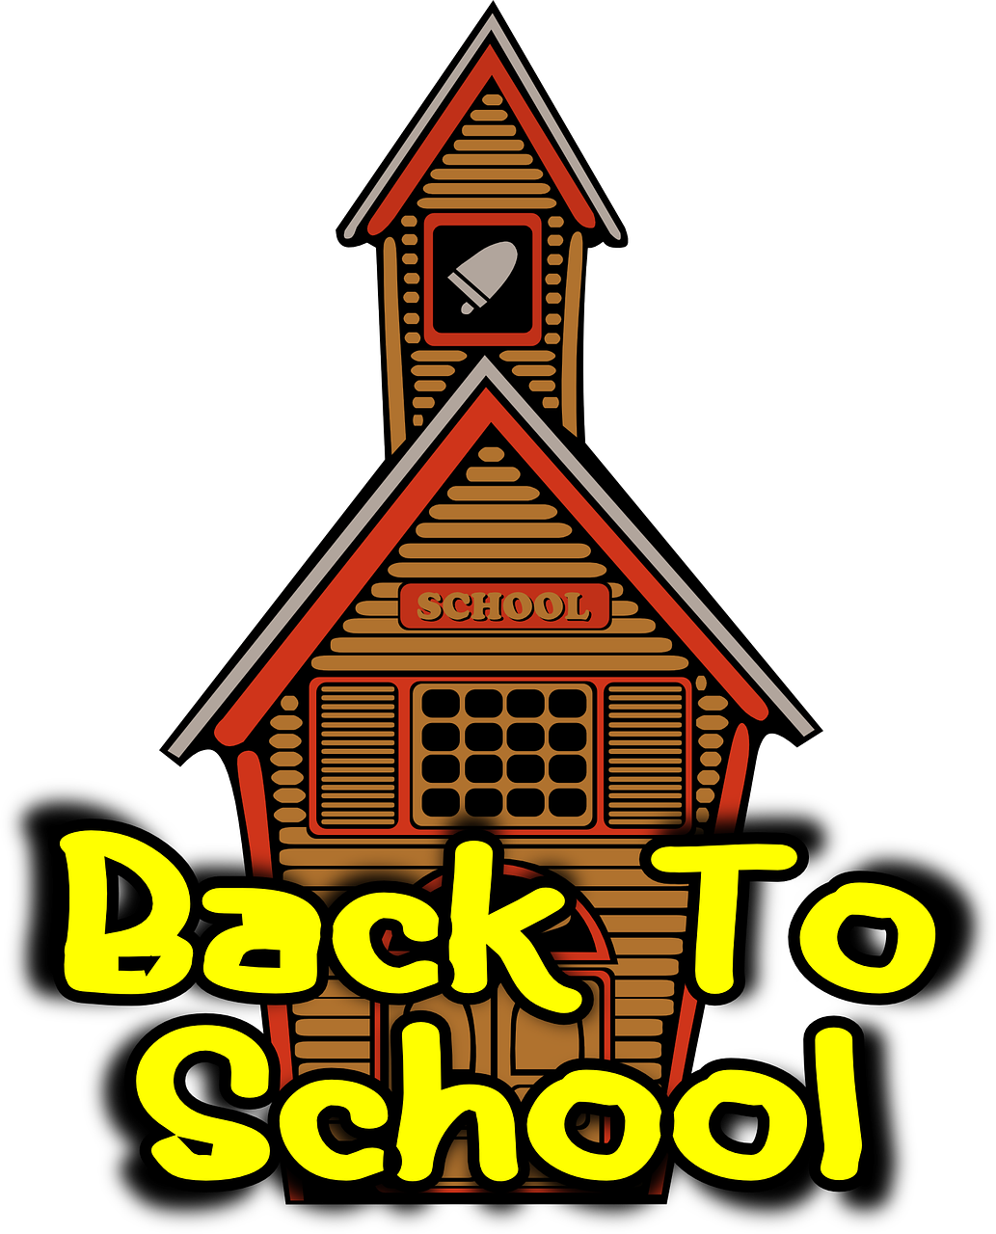
Kindergarten Supply List

1 large zippered backpack without wheels
1 large zippered pencil pouch
1 box of 24 Crayola crayons
4 large-sized glue sticks
1 box of zippered bags (sandwich or gallon size)
3 rolls of paper towels
1 package of baby wipes
3 boxes of tissues

For art/music classes:
An art smock (an old adult-sized t-shirt works great!)- labeled with name
1 composition book (music)- label with name
1 sketch pad (9x12” or 8 x11) label with name
Hard shelled- crayon box
1 box of 24 ct crayons
1 box of washable markers
Black sharpie pens -3

