3rd Grade Supply List: 2023-2024

PLEASE CLEARLY LABEL THE FOLLOWING ITEMS:

- 5 two-pocket plastic folders (1 red, 1 blue, 1 yellow, 1 green, 1 purple)
- 3-ring 1-inch white binder with clear pocket cover
- 2 packs of 12 colored pencils
- 2 boxes of 24 Crayola crayons
- 2 packs of 10 thin, washable markers
- 3 black Sharpie/permanent markers
- 2 plastic pencil/supply boxes (8”x5”x2”)
- 1 pair of scissors (5-inch/student size)
- 1 sketch book, 9”x12” (preferably non-spiral) – if your child’s sketch book from last year still has plenty of clean paper in it, it can be reused
- 2 composition notebooks (wide-ruled, any color)
- 1 green wide-ruled spiral notebook
- Child-sized wired headphones (no ear buds)
- 1 water bottle (plastic reusable, NOT a metal bottle and NOT a Poland Springs-type single use bottle)

THE FOLLOWING ITEMS SHOULD NOT BE LABELED:
- 36 SHARPENED #2 pencils (not mechanical, please)
OPTIONAL
Scan the code to access our Amazon wish list and further help our class!
- 3 large glue sticks
- 1 yellow highlighter
- 1 roll paper towels
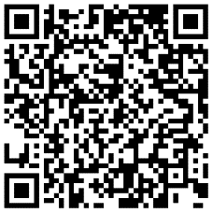
- 3 boxes of Kleenex (at least 144 tissues in each)
- 1 pump bottle hand sanitizer (at least 32 oz.)
- 1 container sanitizing wipes

